# ç

Community Feedback  
Form Template

## Purpose

This tool provides City government practitioners with a template community feedback form for engagement. To learn more, review the Evaluate guide at [engagement-toolkit.phila.gov](http://www.phila.gov/engagement-toolkit).

## Instructions

Set aside 30 minutes to review this template feedback form. Find a comfortable space to think and prepare to sit with questions about your engagement.

Before using this form in your engagement, tailor the prompts and questions below.

## Template feedback form

Thanks for participating in this engagement. You’re invited to share your experience with us, so we can improve future engagements.

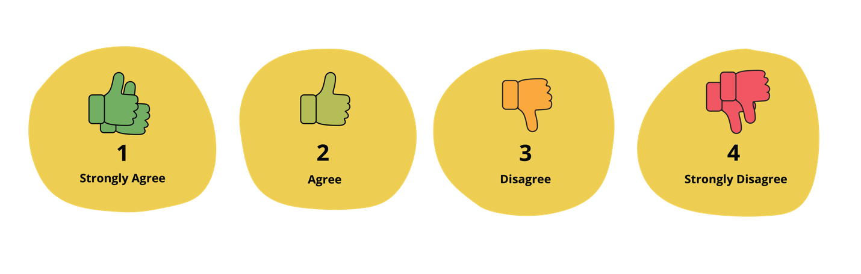

|  |  |  |  |  |
| --- | --- | --- | --- | --- |
| **Circle the option that best describes your response to the prompts below.** | | | | |
| I understood the goals of the engagement. | 1 | 2 | 3 | 4 |
| I received guidance and support to fully participate in the engagement. | 1 | 2 | 3 | 4 |
| I felt like I could make valuable contributions to the engagement. | 1 | 2 | 3 | 4 |
| I felt like I could comfortably share my feelings and thoughts in the engagement. | 1 | 2 | 3 | 4 |
| I felt like my feelings and thoughts were listened to by the facilitators. | 1 | 2 | 3 | 4 |
| The facilitators created a collaborative and inclusive experience in the engagement. | 1 | 2 | 3 | 4 |
| The facilitators set clear expectations for me and others participating in the engagement. | 1 | 2 | 3 | 4 |

Would you participate in a future engagement like this? Why or why not?

Was the date, time, and location of this engagement appropriate?

What did you like most about this engagement? Think about things that made you feel comfortable, hopeful, or valued.

What did you like least about this engagement? Think about things that made you feel disappointed, excluded, or uncomfortable.

Is there anything else you’d like to share about your experience in this engagement?